Nojs on Docker on Heroku

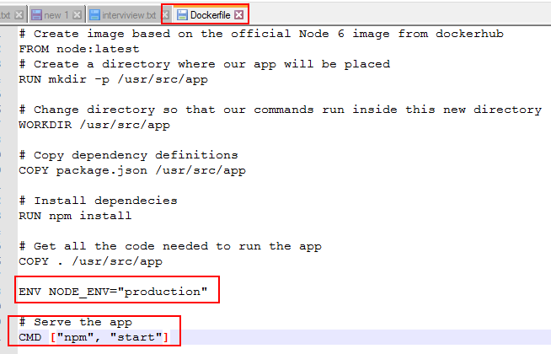

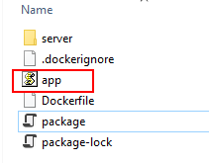

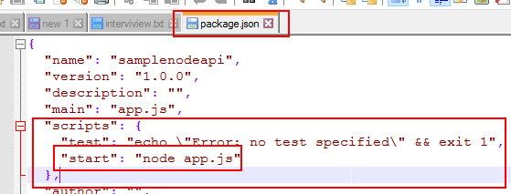

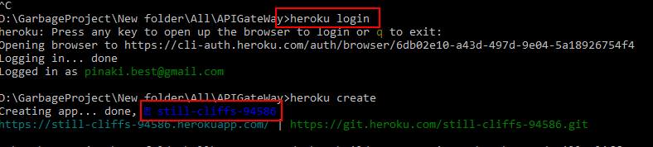

Run these commands

heroku login

heroku create

docker build --tag=registry.heroku.com/still-cliffs-94586/web .

docker push registry.heroku.com/still-cliffs-94586/web

heroku container:release web -a=still-cliffs-94586

heroku open -a=still-cliffs-94586

heroku logs --tail -a=still-cliffs-94586



